Capstone Project Weekly Progress Report

|  |  |
| --- | --- |
| Project Title | Market Based Data Visualization and Analysis |
| Group Name | Group D |
| Student names/Student IDs | Avik Kundal(744823),Jasmeet Kaur(744215),Kirandeep Kaur(742276),Savreet Kaur(742785),Sukhjinder Singh(743143) |
| Reporting Week | 23 sept 2019 to 29 sept 2019 |
| Faculty Supervisor | William Pourmajidi |

# **Tasks Outlined in Previous Weekly Progress Report** (Provide detailed information on the tasks to be completed in this week)

To choose proper libraries of Jupyter Notebook for visualizing Data Set and to concatenate data in test and train sets into a data frame of Pandas library.

# **Progress Made in Reporting Week** (Provide detailed information on the progress that you made in the reporting week. Limit your write-up to no more than two page)

* Home page of Jupyter Notebook
* 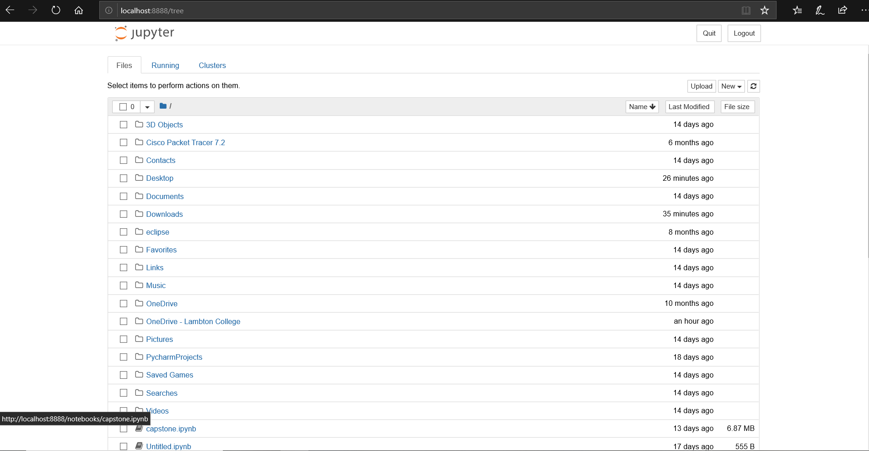
* train.describe() function shows statistics of the training data set.
* test.describe() function shows statistics of the test data set.
* Train.shape, test.shape shows the number of rows and columns of the data set

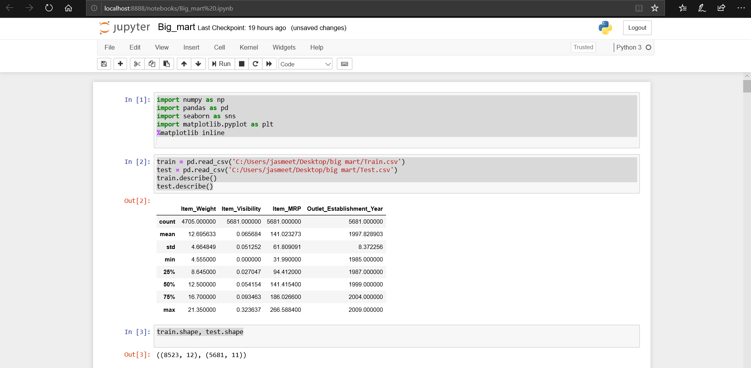

* Train.columns- Get the columns in train data set
* Test.columns – Get the columns in test data set
* pd.concat([train, test], sort = False)- to combine train and test data set and get a combined data frame named Big_Mart.

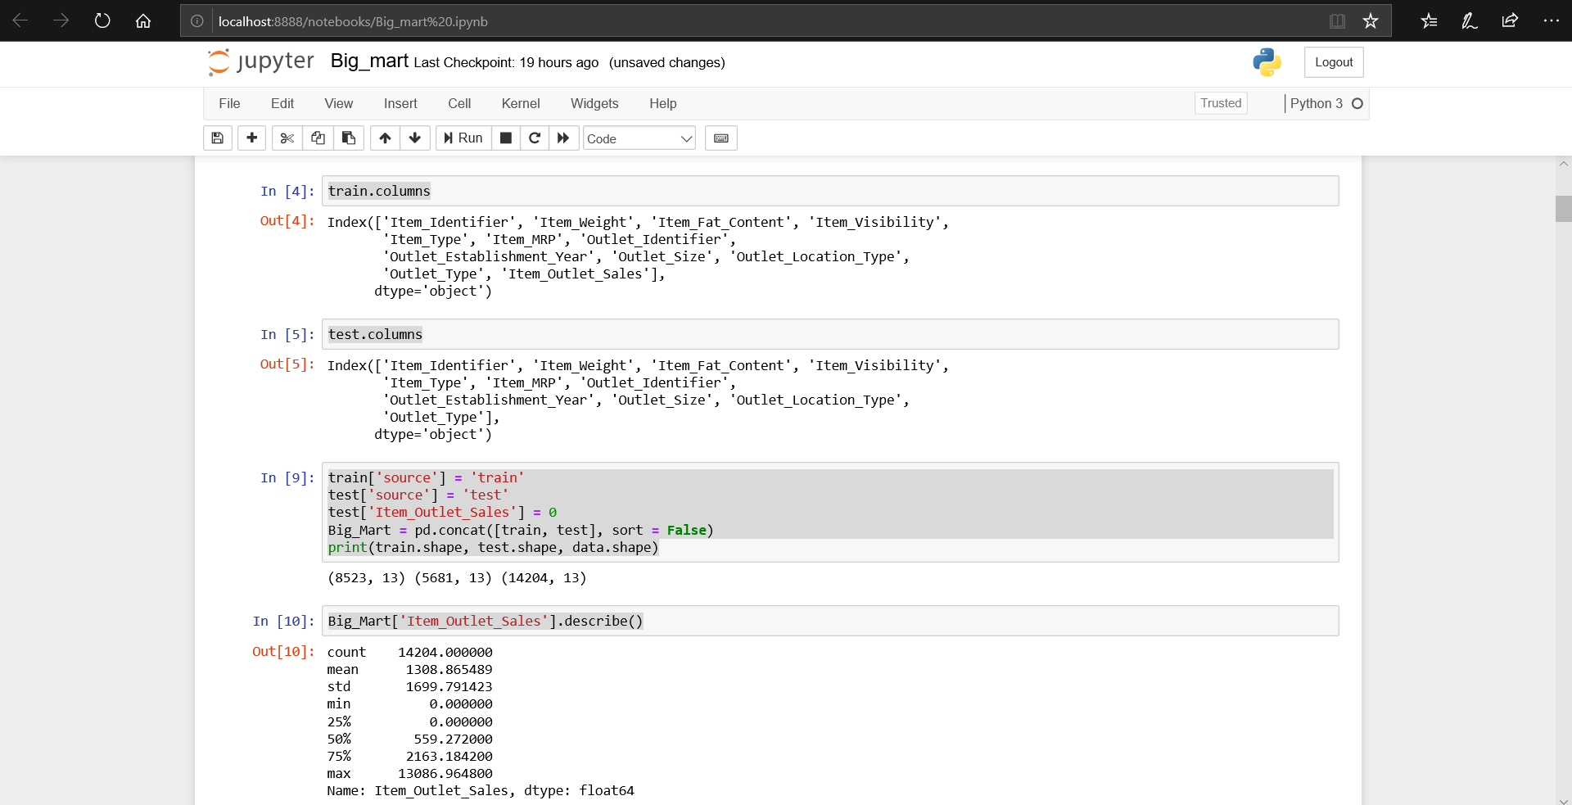

# **Difficulties Encountered in Reporting Week** (Provide detailed information on the difficulties and issues that you encountered in the reporting week. Limit your write-up to no more than one page)

Choosing proper function to count the number of rows and columns in the train and test data set and further to concatenate them into data frame.

# **Tasks to Be Completed in Next Week** (Outline the tasks to be completed in the following week)

To know the data types present the Big_Mart Data Set and to differentiate the categorical and numerical features.